DAD 220 Module Four Major Activity Template

Overview

Complete these steps as you work through the directions for this activity. Replace the bracketed text with your screenshots and brief explanations of the work the screenshots capture. Size each screenshot and its explanation to fit approximately one-quarter of the page with the description written below the screenshot. Review the Template Screenshot Example linked in the guidelines and rubric for this assignment to see how screenshots for your assignment should look.

Before you begin, follow steps one through four from the Module Three Major Activity Guidelines and Rubric only to generate tables for this assignment. Then follow the steps below to complete the activity.

Organize and Analyze Data in Tables

- Import the data from each file into tables.
  - Use the Quantigration RMA database, the three tables you created, and the three CSV files preloaded into Codio.
  - Use the import utility of your database program to load the data from each file into the table of the same name. You'll perform this step three times, once for each table.
    - Reference notes for this step: Import the CSV File into the MySQL table. Use the following line terminators when importing: \r\n. Do not use IGNORE 1 LINES for data that does not have column headers in the first row.
  - Provide the SQL commands you ran against MySQL to complete this step successfully.

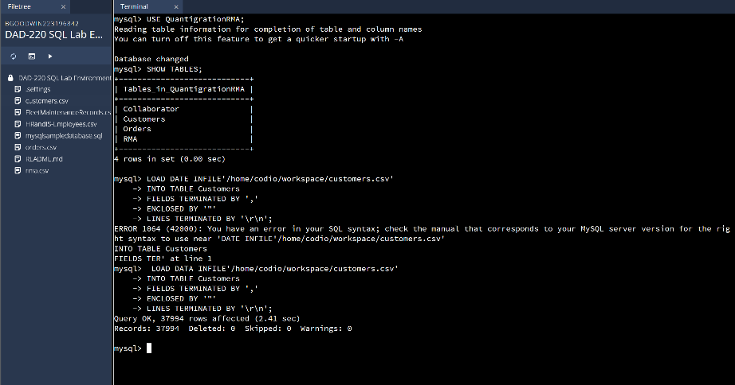
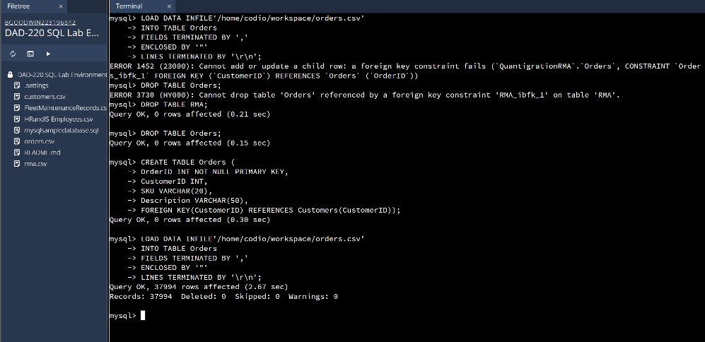
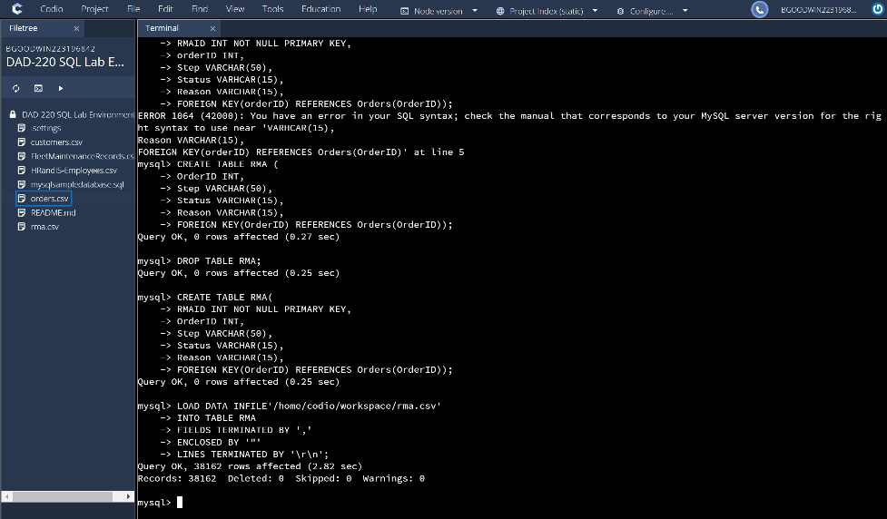
I’m sorry for the three pictures, I had to restructure my tables so that the information would be able to be uploaded and flow between the tables. I used the LOAD DATA INFILE command to take the information and put it into each table, the ‘,’ lets sql know it is a cvs file and the ‘”’ is used to separate the information within it. The ‘\r\n’ makes it so each new piece of information gets a new line which indicates the end of a row.

- Write basic queries against imported tables to organize and analyze targeted data. For each query you run in this step, include a screenshot of the query and its output. Also, include a one- to three-sentence explanation.
  - Write a SQL query that returns the count of orders for customers located only in Framingham, Massachusetts.
    - This query will use a table join between the Customers and Orders tables. The query will also use a WHERE clause.
    - Record an answer to the following question: How many records were returned?
505 records were returned.
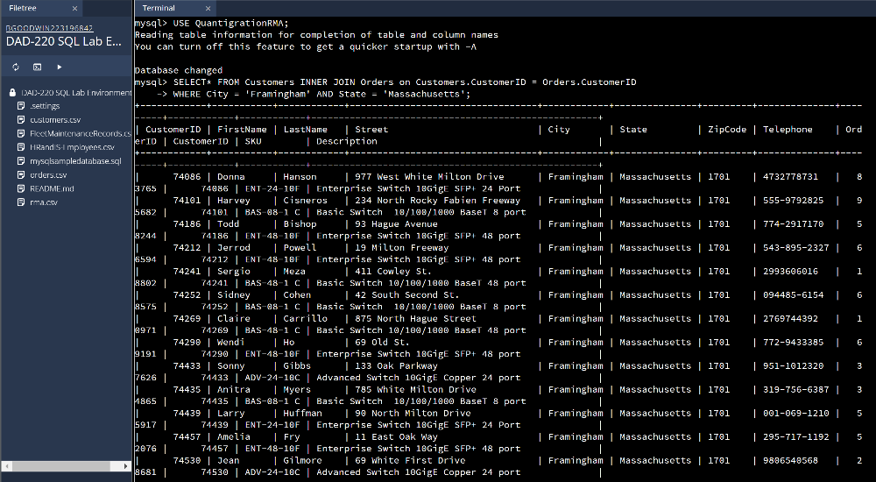
This command joins the customers table with the orders table and returns all the records that meet the parameters which in this case are customers in the town of Framingham and the state of Massachusett’s.
  - Write a SQL query to select all of the customers located in Massachusetts.
    - Use a WHERE clause to limit the number of records in the Customers table to only those who are located in Massachusetts.
    - Record an answer to the following question: How many records were returned?

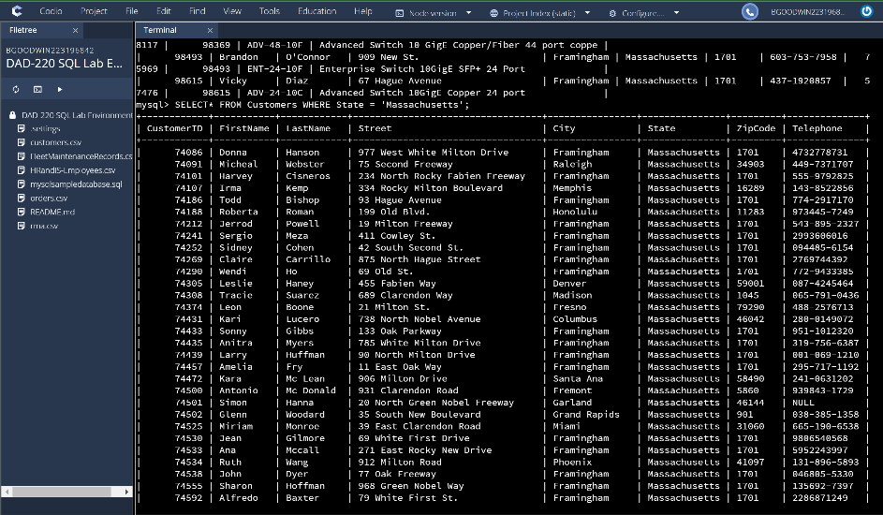
982 records were returned from this query, this time we only needed to use the customer table and limit the search to the state of Massachusetts.
  - Write a SQL query to insert four new records into the Orders and Customers tables using the data below.

Customers Table
CustomerID | FirstName | Lastname | StreetAddress | City | State | ZipCode | Telephone
100004 | Luke | Skywalker | 17 Maiden Lane | New York | NY | 10222 | 212-555-1234
100005 | Winston | Smith | 128 Sycamore Street | Greensboro | NC | 27401 | 919-555-6623
100006 | MaryAnne | Jenkins | 2 Coconut Way | Jupiter | FL | 33458 | 321-555-8907
100007 | Janet | Williams | 58 Redondo Beach Blvd | Torrence | CA | 90501 | 310-555-5678

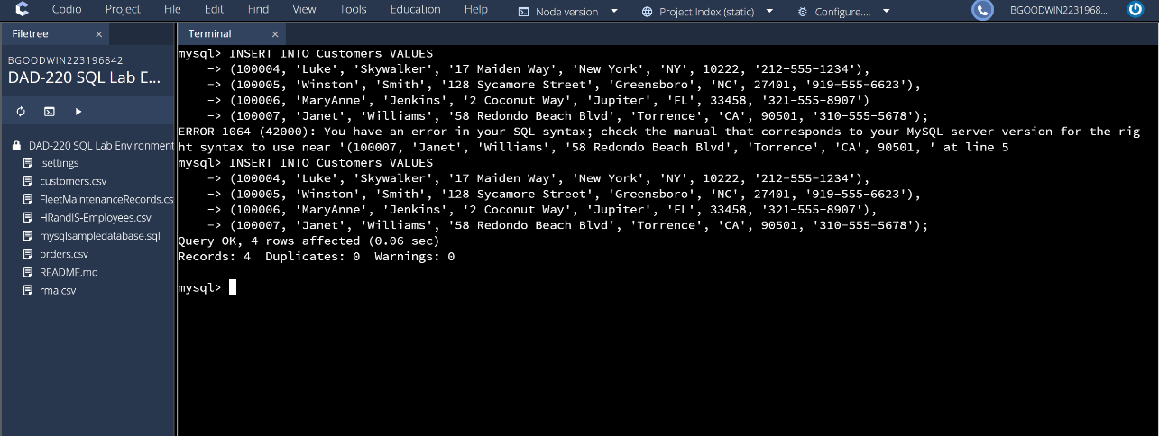
I used the insert into customers table command and the values to indicate what values were being input, then I input each of the values with the corresponding piece of information.
Orders Table
OrderID | CustomerID | SKU | Description
1204305 | 100004 | ADV-24-10C | Advanced Switch 10GigE Copper 24 port
1204306 | 100005 | ADV-48-10F | Advanced Switch 10 GigE Copper/Fiber 44 port copper 4 port fiber
1204307 | 100006 | ENT-24-10F | Enterprise Switch 10GigE SFP+ 24 Port
1204308 | 100007 | ENT-48-10F | Enterprise Switch 10GigE SFP+ 48 port

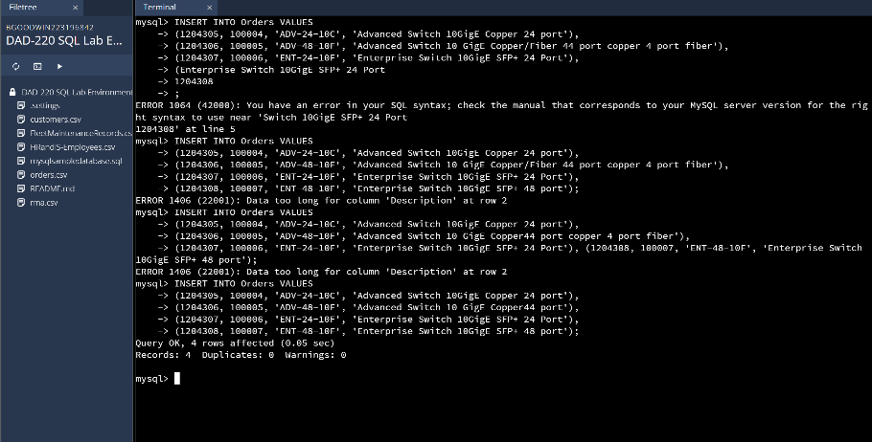

I used the insert into orderss table command and the values to indicate what values were being input, then I input each of the values with the corresponding piece of information.
  - In the Customers table, perform a query to count all records where the city is Woonsocket and the state is Rhode Island.
    - How many records are in the Customers table where the field "city" equals "Woonsocket"?
7 records were returned.

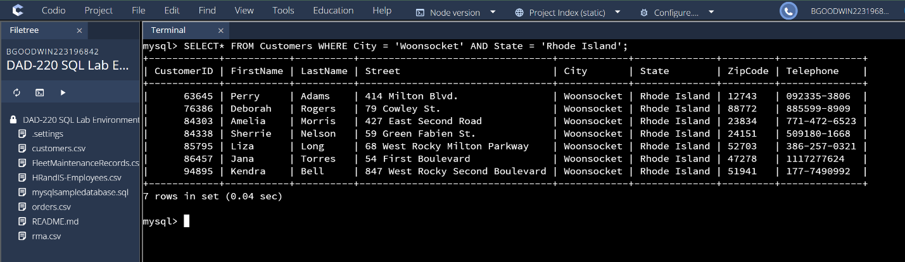
  - In the RMA database, update a customer's records.
    - Write a SQL statement to select the current fields of status and step for the record in the RMA table with an OrderID value of "5175".
      - What are the current status and step?
The current status is pending and the the step is awaiting customer documentation.
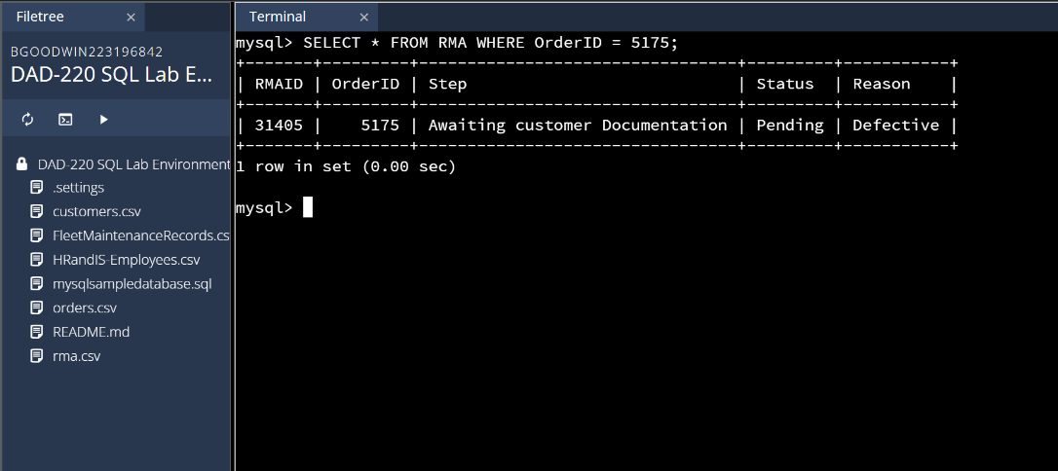
    - Write a SQL statement to update the status and step for the OrderID, 5175 to status = "Complete" and step = "Credit Customer Account".
      - What are the updated status and step values for this record? Provide a screenshot of your work.

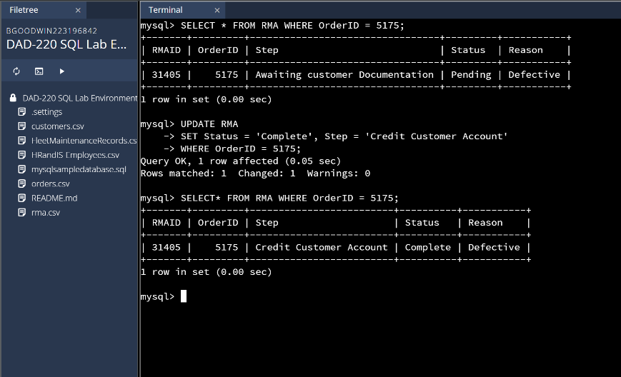
  - Delete RMA records.
    - Write a SQL statement to delete all records with a reason of "Rejected".
      - How many records were deleted? Provide a screenshot of your work.
A delete from RMA table command was used where the reason = ‘rejected’ which affected 596 rows.

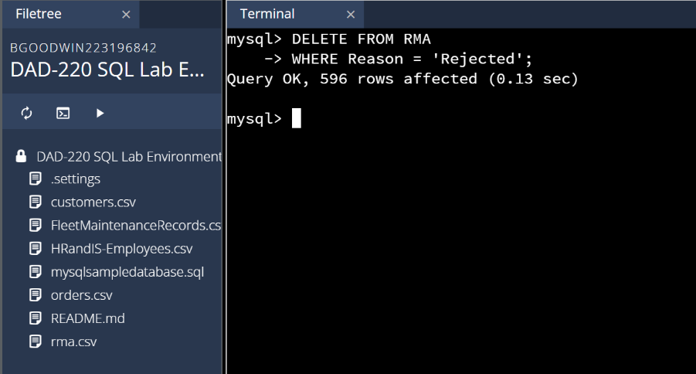
- Create an output file of the required query results.
Write a SQL statement to list the contents of the Orders table and send the output to a file that has a .csv extension.
All records were selected and turned into an output file with a csv extension which means it is readable as text.

